# CCET 3680 Mill Lesson 4 First Exercise

I. Wireframe:

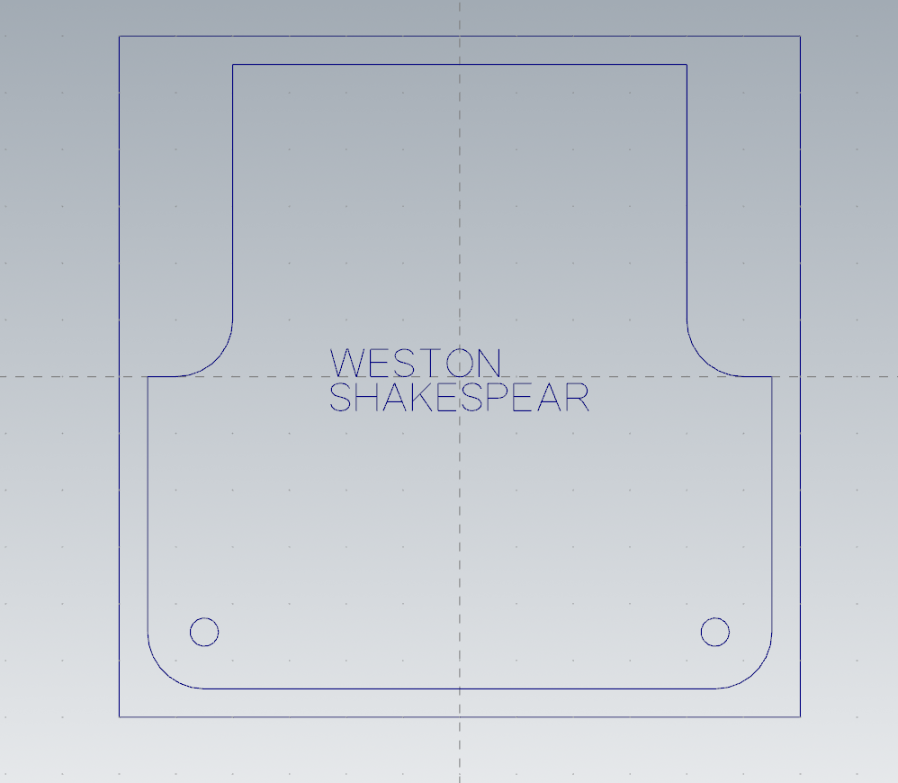

II. Dimensions:

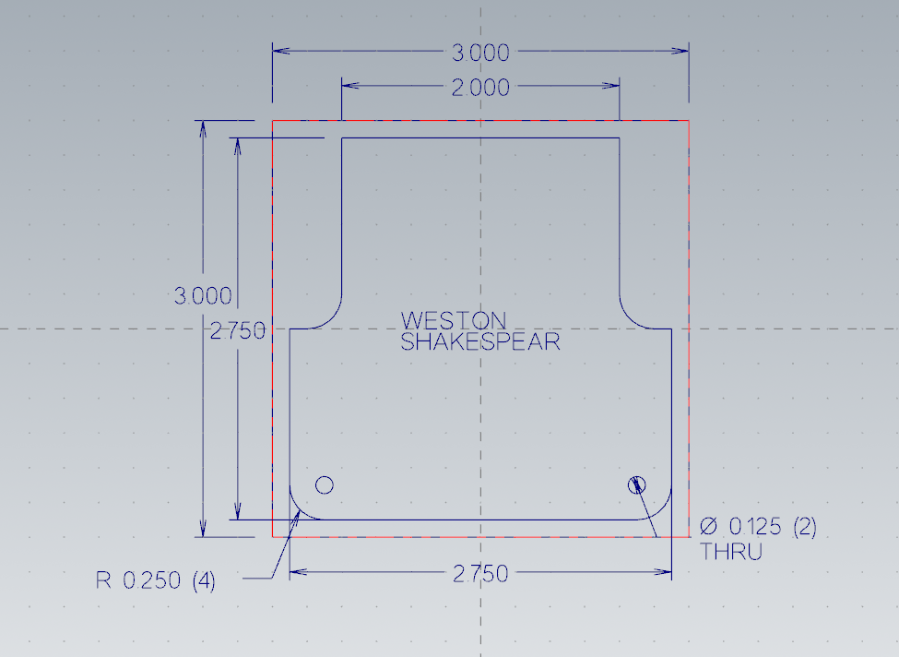

III. Solid:

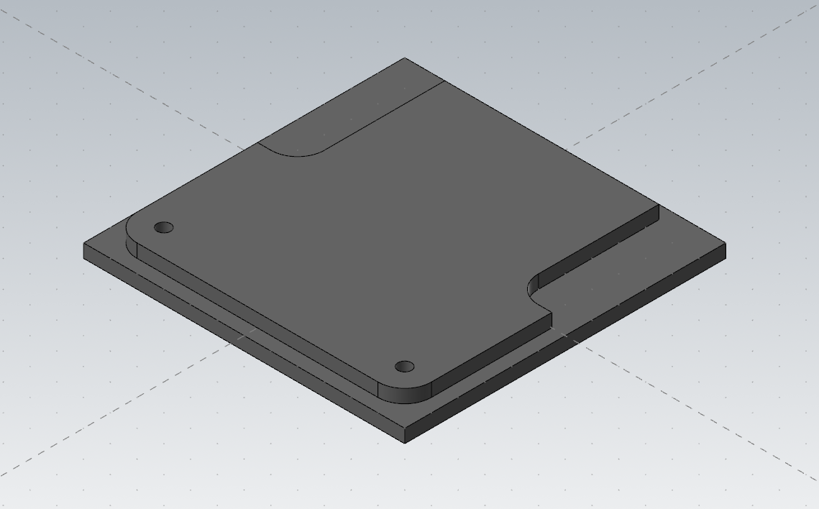

IV. Toolpaths:

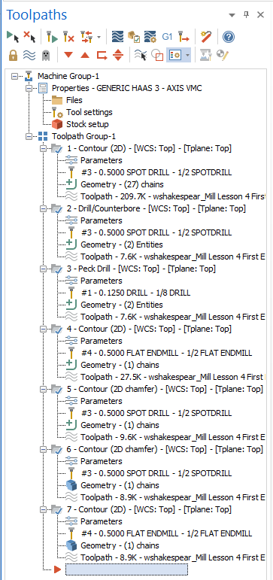

V. Name 2D Contour:

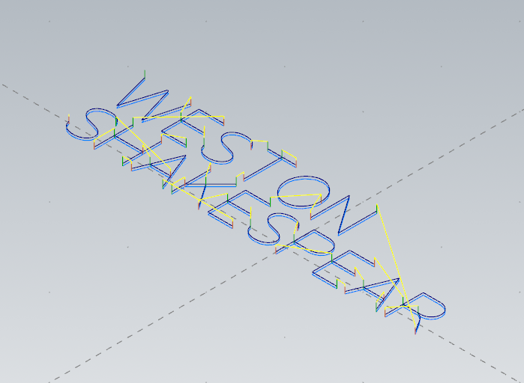

VI. Spot Drill:

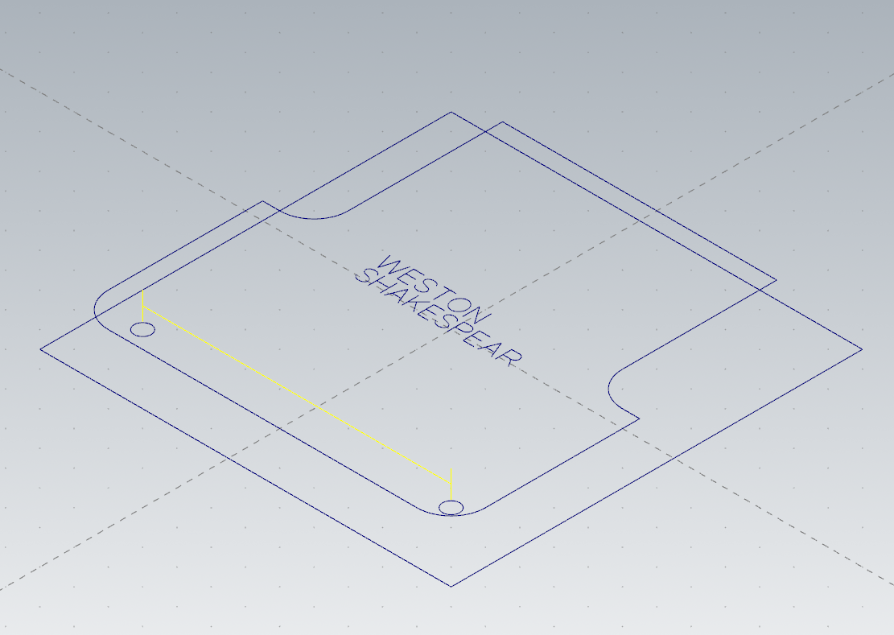

VII. Peck Drill:

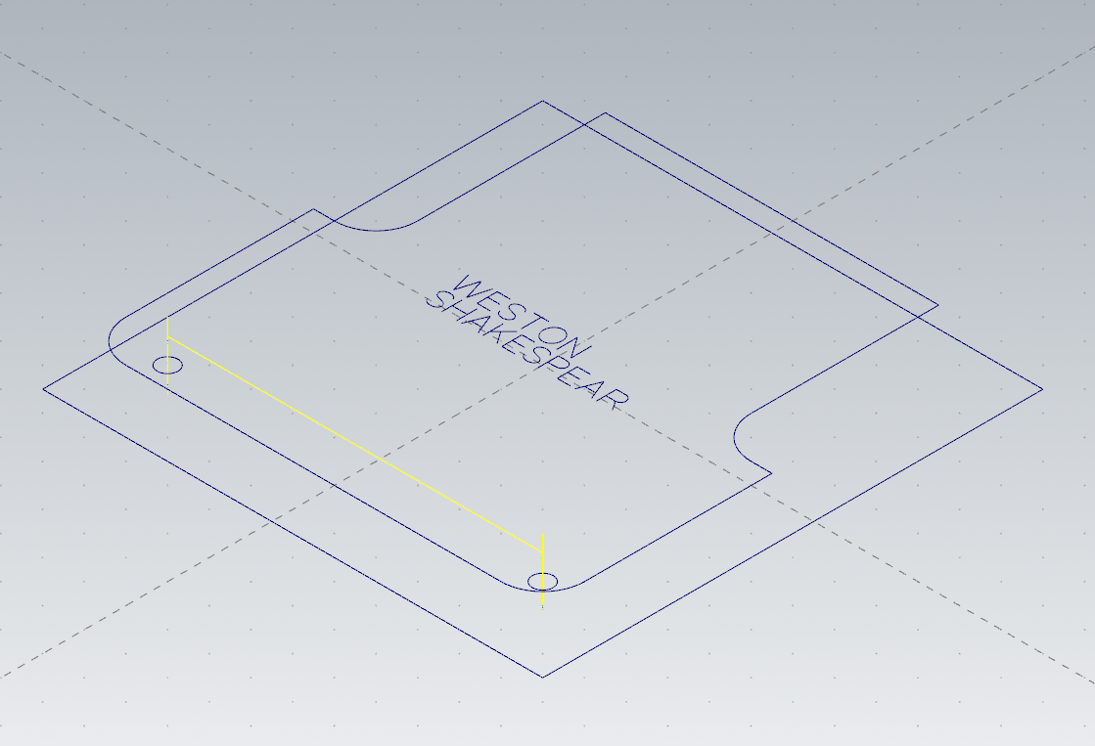

VIII. 2D Contour:

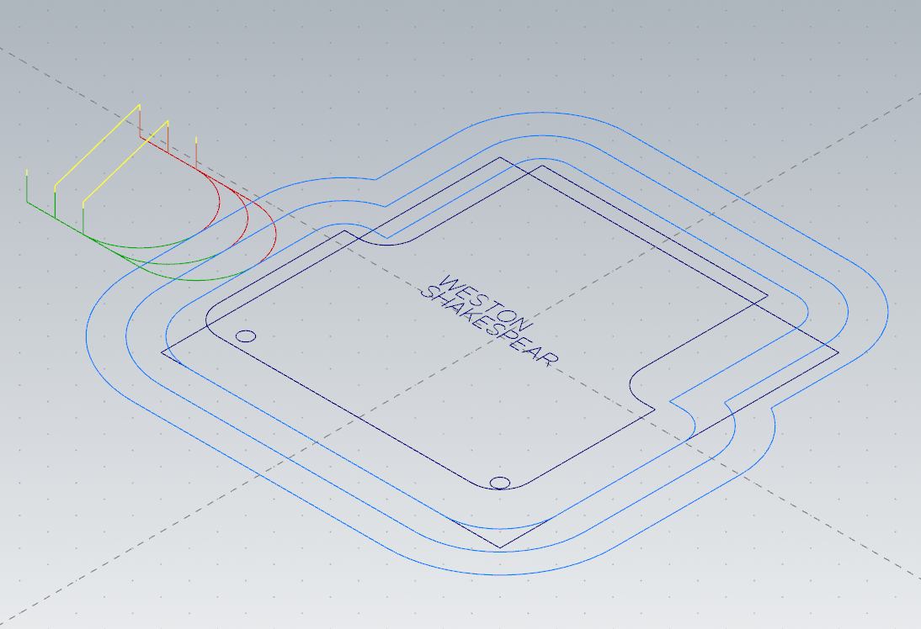

IX. 2D Chamfer Contour:

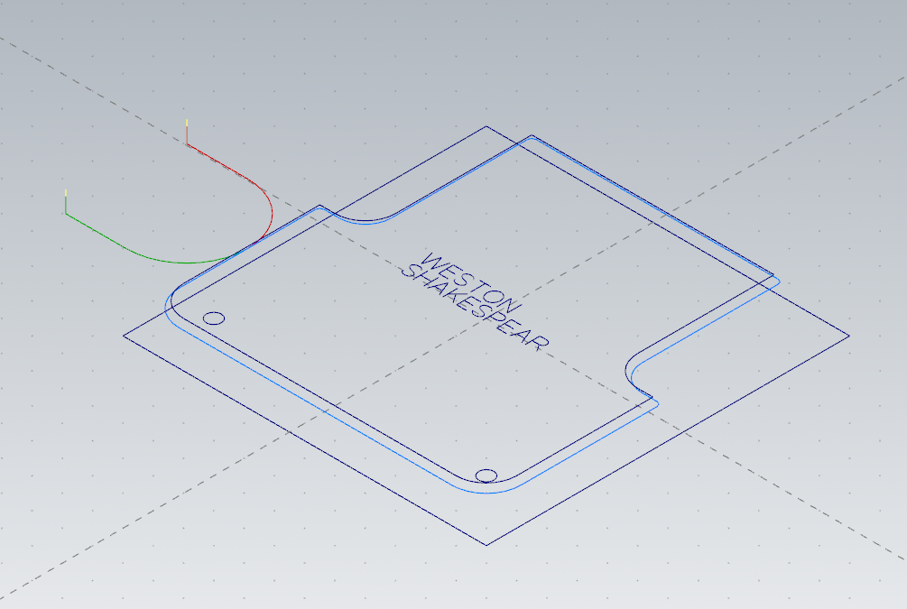

X: 2D Chamfer Contour:

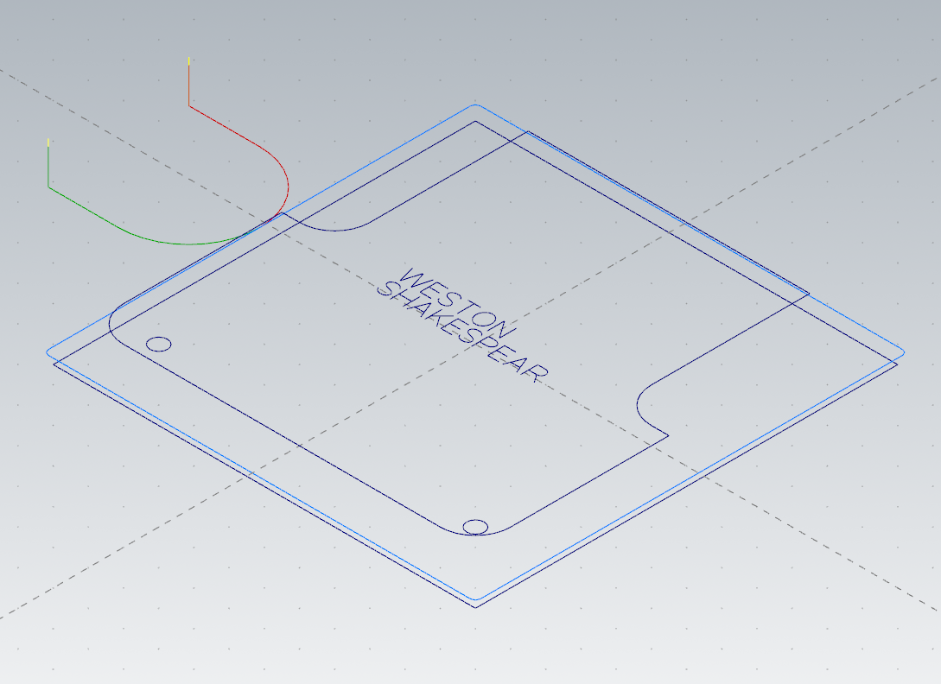

XI: 2D Contour:

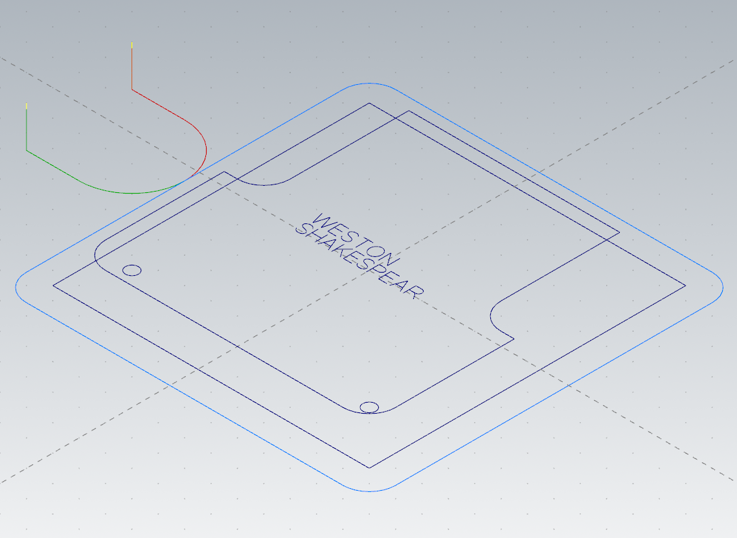

XII. Final Solid:

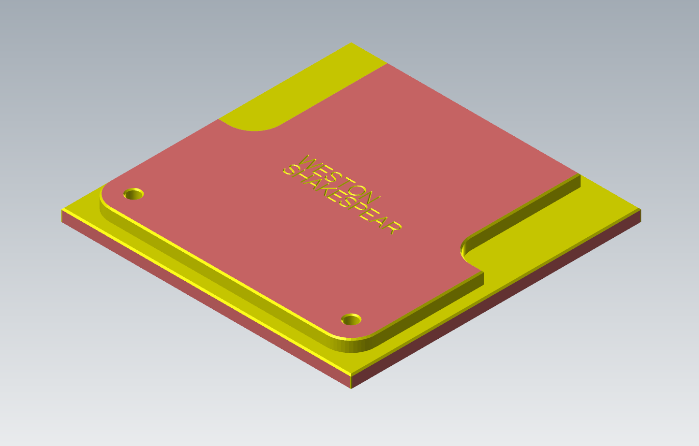

XIII. Method:

I drew two center anchored rectangles and then used offsets to create one copy of the repeating geometry. Then I offset the upper portion and added the fillets and holes.

XIV. GCode Changes

To modify my gcode to be compatible with the machine I first made sure the HAAS 3 axis post processor was selected when exporting the gcode. Then I removed the long lines at the beginning and edited the last G28 home command to not zero the x axis.

XV. Gcode:

%

O33001

(WSHAKESPEAR_MILL LESSON 4 FIRST EXERCISE)

(MATERIAL - ALUMINUM INCH - 6061)

(T3|1/2 SPOTDRILL|H3|D3|TOOL DIA. - .5)

(T1|1/8 DRILL|H1|D1|TOOL DIA. - .125)

(T4|1/2 FLAT ENDMILL|H4|D4|TOOL DIA. - .5)

N100 G20

N110 G0 G17 G40 G49 G80 G90

N120 T3 M6

N130 G187 P3 E.001

N140 G0 G90 G54 X-.5682 Y.1221 S4966 M3

N150 G43 H3 Z.145

N160 G1 Z.118 F6.4

N170 X-.5347 Y-.0017 F500.

N180 X-.4972 Y.1221

N190 X-.4926

N200 X-.455 Y-.0017

N210 X-.4216 Y.1221

N220 Z.138 F6.4

N230 G0 Z.145

N240 X-.3935 Y.0628

N250 G1 Z.118

N260 X-.3191 F500.

N270 Z.138 F6.4

N280 G0 Z.145

N290 X-.2866 Y.0293

N300 G1 Z.118

N310 X-.2833 Y.0205 F500.

N320 X-.2778 Y.0123

N330 X-.2687 Y.0055

N340 X-.2571 Y.0014

N350 X-.2442 Y0.

N360 X-.2278 Y.0022

N370 X-.2151 Y.0088

N380 X-.2066 Y.0185

N390 X-.2034 Y.0294

N400 X-.2074 Y.0421

N410 X-.2096 Y.0448

N420 X-.2174 Y.0512

N430 X-.2284 Y.056

N440 X-.2622 Y.0654

N450 X-.276 Y.0736

N460 X-.2797 Y.0776

N470 X-.2835 Y.0848

N480 X-.2848 Y.0929

N490 X-.2815 Y.1037

N500 X-.2726 Y.1128

N510 X-.2599 Y.1186

N520 X-.2442 Y.1208

N530 X-.231 Y.1195

N540 X-.2193 Y.1149

N550 X-.2102 Y.1072

N560 X-.2045 Y.0971

N570 Z.138 F6.4

N580 G0 Z.145

N590 X-.1747 Y.1203

N600 G1 Z.118

N610 X-.0835 F500.

N620 Z.138 F6.4

N630 G0 Z.145

N640 X-.1288

N650 G1 Z.118

N660 Y-.0017 F500.

N670 Z.138 F6.4

N680 G0 Z.145

N690 X-.1268 Y-.0279

N700 G1 Z.118

N710 X-.2087 Y-.1099 F500.

N720 Z.138 F6.4

N730 G0 Z.145

N740 Y-.1517

N750 G1 Z.118

N760 Y-.0279 F500.

N770 Z.138 F6.4

N780 G0 Z.145

N790 X-.1753 Y-.0765

N800 G1 Z.118

N810 X-.1228 Y-.1517 F500.

N820 Z.138 F6.4

N830 G0 Z.145

N840 X-.0951 Y-.0872

N850 G1 Z.118

N860 X-.0207 F500.

N870 Z.138 F6.4

N880 G0 Z.145

N890 X.0118 Y-.1207

N900 G1 Z.118

N910 X.0152 Y-.1295 F500.

N920 X.0206 Y-.1377

N930 X.0298 Y-.1445

N940 X.0413 Y-.1486

N950 X.0542 Y-.15

N960 X.0706 Y-.1478

N970 X.0833 Y-.1412

N980 X.0919 Y-.1315

N990 X.095 Y-.1206

N1000 X.091 Y-.1079

N1010 X.0889 Y-.1052

N1020 X.0811 Y-.0988

N1030 X.07 Y-.094

N1040 X.0363 Y-.0846

N1050 X.0224 Y-.0764

N1060 X.0187 Y-.0724

N1070 X.0149 Y-.0652

N1080 X.0137 Y-.0571

N1090 X.017 Y-.0463

N1100 X.0258 Y-.0372

N1110 X.0385 Y-.0314

N1120 X.0542 Y-.0292

N1130 X.0674 Y-.0305

N1140 X.0791 Y-.0351

N1150 X.0883 Y-.0428

N1160 X.0939 Y-.0529

N1170 Z.138 F6.4

N1180 G0 Z.145

N1190 X.1235 Y-.0942

N1200 G1 Z.118

N1210 X.1711 F500.

N1220 X.1843 Y-.0921

N1230 X.1965 Y-.0857

N1240 X.2054 Y-.0754

N1250 X.2089 Y-.062

N1260 X.2054 Y-.0485

N1270 X.1965 Y-.0381

N1280 X.1843 Y-.0317

N1290 X.1711 Y-.0297

N1300 X.1235

N1310 Y-.1517

N1320 Z.138 F6.4

N1330 G0 Z.145

N1340 X.2373 Y-.0872

N1350 G1 Z.118

N1360 X.3117 F500.

N1370 Z.138 F6.4

N1380 G0 Z.145

N1390 X.3611 Y-.1099

N1400 G1 Z.118

N1410 X.4264 F500.

N1420 Z.138 F6.4

N1430 G0 Z.145

N1440 X.4438 Y-.1517

N1450 G1 Z.118

N1460 X.3938 Y-.0279 F500.

N1470 X.3437 Y-.1517

N1480 Z.138 F6.4

N1490 G0 Z.145

N1500 X.3163 Y-.15

N1510 G1 Z.118

N1520 X.2373 F500.

N1530 Y-.0297

N1540 X.3163

N1550 Z.138 F6.4

N1560 G0 Z.145

N1570 X.4721 Y-.0943

N1580 G1 Z.118

N1590 X.5273 F500.

N1600 X.5402 Y-.0921

N1610 X.5511 Y-.0856

N1620 X.5587 Y-.0753

N1630 X.5616 Y-.0621

N1640 X.5587 Y-.0488

N1650 X.5511 Y-.0388

N1660 X.5402 Y-.0323

N1670 X.5273 Y-.0298

N1680 X.4721

N1690 Y-.1517

N1700 Z.138 F6.4

N1710 G0 Z.145

N1720 X.5201 Y-.0943

N1730 G1 Z.118

N1740 X.5335 Y-.1018 F500.

N1750 X.5436 Y-.1134

N1760 X.5682 Y-.1517

N1770 Z.138 F6.4

N1780 G0 Z.145

N1790 X.1719 Y.1221

N1800 G1 Z.118

N1810 Y-.0017 F500.

N1820 X.0847 Y.1221

N1830 Y-.0017

N1840 Z.138 F6.4

N1850 G0 Z.145

N1860 X.0565 Y.0599

N1870 G1 Z.118

N1880 X.0525 Y.0827 F500.

N1890 X.0521 Y.0838

N1900 X.0469 Y.0943

N1910 X.0399 Y.1033

N1920 X.0221 Y.1165

N1930 X.0117 Y.1203

N1940 X.0007 Y.1215

N1950 X-.0192 Y.1175

N1960 X-.0213 Y.1165

N1970 X-.0391 Y.1033

N1980 X-.0513 Y.0838

N1990 X-.0546 Y.0721

N2000 X-.0557 Y.0599

N2010 X-.0517 Y.0374

N2020 X-.0513 Y.0362

N2030 X-.0391 Y.0167

N2040 X-.0308 Y.0091

N2050 X-.0213 Y.0035

N2060 X-.0108 Y0.

N2070 X.0007 Y-.0012

N2080 X.0205 Y.0028

N2090 X.0221 Y.0035

N2100 X.0316 Y.0091

N2110 X.0399 Y.0167

N2120 X.0521 Y.0362

N2130 X.0554 Y.0476

N2140 X.0565 Y.0599

N2150 Z.138 F6.4

N2160 G0 Z.145

N2170 X-.0161 Y-.0297

N2180 G1 Z.118

N2190 X-.0951 F500.

N2200 Y-.15

N2210 X-.0161

N2220 Z.138 F6.4

N2230 G0 Z.145

N2240 X-.237 Y-.1517

N2250 G1 Z.118

N2260 X-.287 Y-.0279 F500.

N2270 X-.3371 Y-.1517

N2280 Z.138 F6.4

N2290 G0 Z.145

N2300 X-.3652

N2310 G1 Z.118

N2320 Y-.0279 F500.

N2330 Z.138 F6.4

N2340 G0 Z.145

N2350 X-.3145 Y0.

N2360 G1 Z.118

N2370 X-.3935 F500.

N2380 Y.1203

N2390 X-.3145

N2400 Z.138 F6.4

N2410 G0 Z.145

N2420 X-.4559 Y-.0279

N2430 G1 Z.118

N2440 Y-.1517 F500.

N2450 Z.138 F6.4

N2460 G0 Z.145

N2470 Y-.0872

N2480 G1 Z.118

N2490 X-.3652 F500.

N2500 Z.138 F6.4

N2510 G0 Z.145

N2520 X-.3197 Y-.1099

N2530 G1 Z.118

N2540 X-.2544 F500.

N2550 Z.138 F6.4

N2560 G0 Z.145

N2570 X-.4856 Y-.0529

N2580 G1 Z.118

N2590 X-.4912 Y-.0428 F500.

N2600 X-.5004 Y-.0351

N2610 X-.5121 Y-.0305

N2620 X-.5253 Y-.0292

N2630 X-.541 Y-.0314

N2640 X-.5537 Y-.0372

N2650 X-.5625 Y-.0463

N2660 X-.5659 Y-.0571

N2670 X-.5619 Y-.0709

N2680 X-.5608 Y-.0724

N2690 X-.5488 Y-.082

N2700 X-.5432 Y-.0846

N2710 X-.5095 Y-.094

N2720 X-.4949 Y-.1012

N2730 X-.4907 Y-.1052

N2740 X-.4851 Y-.1157

N2750 X-.4845 Y-.1206

N2760 X-.4877 Y-.1315

N2770 X-.4962 Y-.1412

N2780 X-.5089 Y-.1478

N2790 X-.5253 Y-.15

N2800 X-.5382 Y-.1486

N2810 X-.5498 Y-.1445

N2820 X-.5589 Y-.1377

N2830 X-.5643 Y-.1295

N2840 X-.5677 Y-.1207

N2850 Z.138 F6.4

N2860 G0 Z.145

N2870 M8

N2880 G187 P3 E.001

N2890 X-1.125 Y-1.125 Z.25

N2900 Z.15

N2910 G99 G81 Z.05 R.15 F246.6

N2920 X1.125

N2930 G80

N2940 Z.25

N2950 M5

N2960 G91 G28 Z0. M9

N2970 M01

N2980 T1 M6

N2990 G187 P3 E.001

N3000 G0 G90 G54 X-1.125 Y-1.125 S2139 M3

N3010 G43 H1 Z.25

N3020 Z.15

N3030 G99 G83 Z-.155 R.15 Q.0375 F4.1

N3040 X1.125

N3050 G80

N3060 Z.25

N3070 M5

N3080 G91 G28 Z0.

N3090 M01

N3100 T4 M6

N3110 G187 P3 E.001

N3120 G0 G90 G54 X-3.125 Y-1.0625 S4966 M3

N3130 G43 H4 Z.25

N3140 Z.2

N3150 G1 Z0. F6.4

N3160 X-2.625 F500.

N3170 G3 X-2.125 Y-.5625 I0. J.5

N3180 G1 Y0.

N3190 G2 X-1.75 Y.6495 I.75 J0.

N3200 G1 Y1.375

N3210 G2 X-1. Y2.125 I.75 J0.

N3220 G1 X1.

N3230 G2 X1.75 Y1.375 I0. J-.75

N3240 G1 Y.6495

N3250 G2 X2.125 Y0. I-.375 J-.6495

N3260 G1 Y-1.125

N3270 G2 X1.125 Y-2.125 I-1. J0.

N3280 G1 X-1.125

N3290 G2 X-2.125 Y-1.125 I0. J1.

N3300 G1 Y-.5625

N3310 G3 X-2.625 Y-.0625 I-.5 J0.

N3320 G1 X-3.125

N3330 Z.2 F6.4

N3340 G0 Z.25

N3350 X-2.875 Y-1.0625

N3360 Z.2

N3370 G1 Z0.

N3380 X-2.375 F500.

N3390 G3 X-1.875 Y-.5625 I0. J.5

N3400 G1 Y0.

N3410 G2 X-1.5 Y.4841 I.5 J0.

N3420 G1 Y1.375

N3430 G2 X-1. Y1.875 I.5 J0.

N3440 G1 X1.

N3450 G2 X1.5 Y1.375 I0. J-.5

N3460 G1 Y.4841

N3470 G2 X1.875 Y0. I-.125 J-.4841

N3480 G1 Y-1.125

N3490 G2 X1.125 Y-1.875 I-.75 J0.

N3500 G1 X-1.125

N3510 G2 X-1.875 Y-1.125 I0. J.75

N3520 G1 Y-.5625

N3530 G3 X-2.375 Y-.0625 I-.5 J0.

N3540 G1 X-2.875

N3550 Z.2 F6.4

N3560 G0 Z.25

N3570 X-2.625 Y-1.0625

N3580 Z.2

N3590 G1 Z0.

N3600 X-2.125 F500.

N3610 G3 X-1.625 Y-.5625 I0. J.5

N3620 G1 Y0.

N3630 G2 X-1.375 Y.25 I.25 J0.

N3640 G1 X-1.25

N3650 Y1.375

N3660 G2 X-1. Y1.625 I.25 J0.

N3670 G1 X1.

N3680 G2 X1.25 Y1.375 I0. J-.25

N3690 G1 Y.25

N3700 X1.375

N3710 G2 X1.625 Y0. I0. J-.25

N3720 G1 Y-1.125

N3730 G2 X1.125 Y-1.625 I-.5 J0.

N3740 G1 X-1.125

N3750 G2 X-1.625 Y-1.125 I0. J.5

N3760 G1 Y-.5625

N3770 G3 X-2.125 Y-.0625 I-.5 J0.

N3780 G1 X-2.625

N3790 Z.2 F6.4

N3800 G0 Z.25

N3810 M5

N3820 G91 G28 Z0.

N3830 M01

N3840 T3 M6

N3850 G187 P3 E.001

N3860 G0 G90 G54 X-2.41 Y-1.0625 S4966 M3

N3870 G43 H3 Z.25

N3880 Z.2

N3890 G1 Z.075 F6.4

N3900 X-1.91 F500.

N3910 G3 X-1.41 Y-.5625 I0. J.5

N3920 G1 Y0.

N3930 G2 X-1.375 Y.035 I.035 J0.

N3940 G1 X-1.25

N3950 G3 X-1.035 Y.25 I0. J.215

N3960 G1 Y1.375

N3970 G2 X-1. Y1.41 I.035 J0.

N3980 G1 X1.

N3990 G2 X1.035 Y1.375 I0. J-.035

N4000 G1 Y.25

N4010 G3 X1.25 Y.035 I.215 J0.

N4020 G1 X1.375

N4030 G2 X1.41 Y0. I0. J-.035

N4040 G1 Y-1.125

N4050 G2 X1.125 Y-1.41 I-.285 J0.

N4060 G1 X-1.125

N4070 G2 X-1.41 Y-1.125 I0. J.285

N4080 G1 Y-.5625

N4090 G3 X-1.91 Y-.0625 I-.5 J0.

N4100 G1 X-2.41

N4110 Z.2 F6.4

N4120 G0 Z.25

N4130 G187 P3 E.001

N4140 X-2.535 Y-.5

N4150 Z.2

N4160 G1 Z-.05

N4170 X-2.035 F500.

N4180 G3 X-1.535 Y0. I0. J.5

N4190 G1 Y1.5

N4200 G2 X-1.5 Y1.535 I.035 J0.

N4210 G1 X1.5

N4220 G2 X1.535 Y1.5 I0. J-.035

N4230 G1 Y-1.5

N4240 G2 X1.5 Y-1.535 I-.035 J0.

N4250 G1 X-1.5

N4260 G2 X-1.535 Y-1.5 I0. J.035

N4270 G1 Y0.

N4280 G3 X-2.035 Y.5 I-.5 J0.

N4290 G1 X-2.535

N4300 Z.2 F6.4

N4310 G0 Z.25

N4320 M5

N4330 G91 G28 Z0.

N4340 M01

N4350 T4 M6

N4360 G187 P3 E.001

N4370 G0 G90 G54 X-2.75 Y-.5 S4966 M3

N4380 G43 H4 Z.25

N4390 Z.2

N4400 G1 Z-.14 F6.4

N4410 X-2.25 F500.

N4420 G3 X-1.75 Y0. I0. J.5

N4430 G1 Y1.5

N4440 G2 X-1.5 Y1.75 I.25 J0.

N4450 G1 X1.5

N4460 G2 X1.75 Y1.5 I0. J-.25

N4470 G1 Y-1.5

N4480 G2 X1.5 Y-1.75 I-.25 J0.

N4490 G1 X-1.5

N4500 G2 X-1.75 Y-1.5 I0. J.25

N4510 G1 Y0.

N4520 G3 X-2.25 Y.5 I-.5 J0.

N4530 G1 X-2.75

N4540 Z.2 F6.4

N4550 G0 Z.25

N4560 M5

N4570 G91 G28 Z0.

N4580 G28 Y0.

N4590 M30

%